**MUST use Windows 64 bits System**

1. Download and Install Python2.7.x from https://www.python.org/downloads/windows/ or from the libraries.
2. Install pip if not pre-installed. See <https://pip.pypa.io/en/stable/installing/>
3. Install all the packages using the wheels in libraries by pip.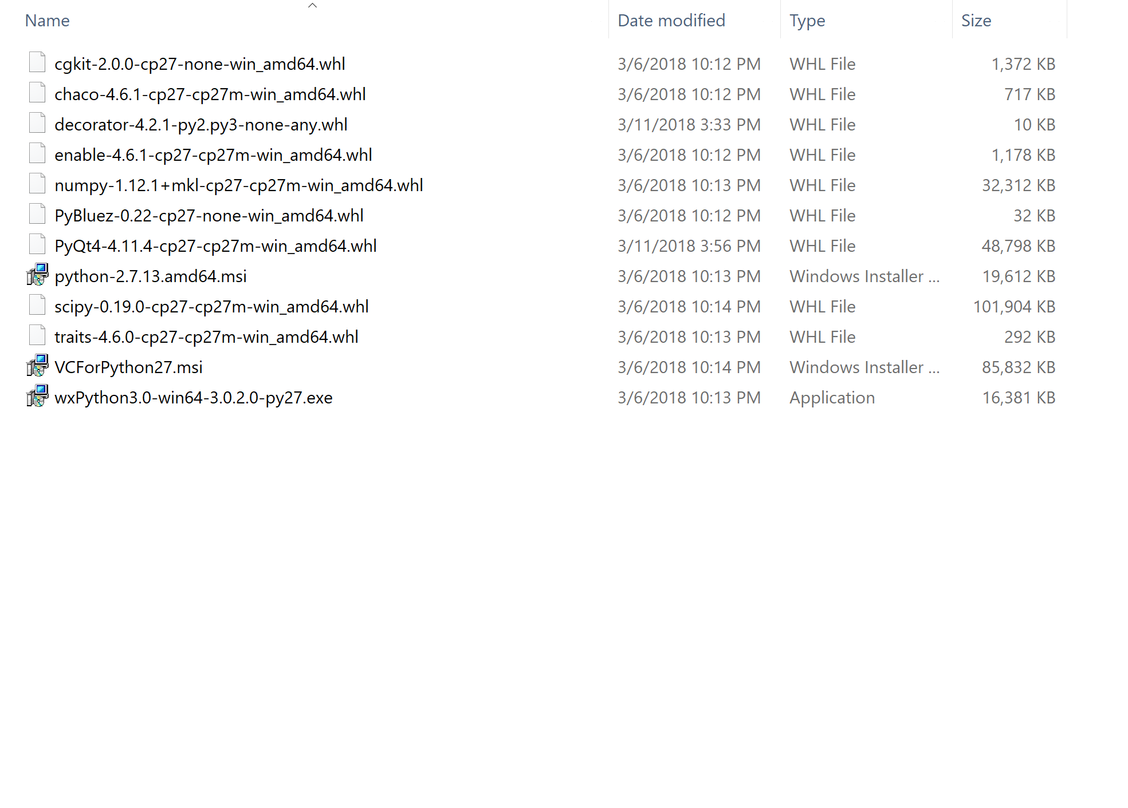
4. Add

from traits.etsconfig.api import ETSConfig

ETSConfig.toolkit = 'wx'

to the GUI file before importing any trait related modules if not already there.

1. Import all the traitsui/traits modules through traitsui/traits instead of enthought.xxx

Ex.

Change

from enthought.traits.ui.wx.editor_factory import EditorFactory

from enthought.traits.ui.wx.button_editor import SimpleEditor as SimpleButtonEditor

from enthought.traits.ui.wx.button_editor import CustomEditor as CustomButtonEditor

from enthought.traits.api import Str, Range, Enum, Property, Instance

from enthought.traits.ui.api import View

from enthought.traits.ui.ui_traits import AView, Image

INTO

from traitsui.wx.editor_factory import EditorFactory

from traitsui.wx.button_editor import SimpleEditor as SimpleButtonEditor

from traitsui.wx.button_editor import CustomEditor as CustomButtonEditor

from traits.api import Str, Range, Enum, Property, Instance

from traitsui.api import View

from traitsui.ui_traits import AView, Image

Q&A

1. If you are using **Windows 32 bits** system, install all the packages with **correct version** (Yes they are old) using pip.
2. No, you cannot use Mac Os.